**GREENHOUSE MONITORING SYSTEM**

**By**

***Bhushan .R. Bhabal, Roll No. 03,***

***Kartik .V. Chopade, Roll No. 06,***

***Vinit .V. Damodar, Roll No. 07***

**What is IOT?**

Over the past few years, IoT has become one of the most important technologies of the 21st century. Now that we can connect everyday objects—kitchen appliances, cars, thermostats, baby monitors—to the internet via embedded devices, seamless communication is possible between people, processes, and things.

By means of low-cost computing, the cloud, big data, analytics, and mobile technologies, physical things can share and collect data with minimal human intervention. In this hyperconnected world, digital systems can record, monitor, and adjust each interaction between connected things. The physical world meets the digital world—and they cooperate.

**IOT in Green-House?**

* Green House technology provides a controlled and favorite environment for crop to grow and yield high in all seasons.
* Saves crop from cold in winters from heat in summers and from rain in monsoon seasons
* Environments can be suitably modified as per the requirements of the crop.

**History of Green-House**

The French Botanist Charles Lucien Bonaparte is often credited with building the first practical modern greenhouse in Leiden, Holland during the 1800s to grow medicinal tropical plants.

**Green-House Automation**

 A climate control system automates the greenhouse to reach the desired temperature as required by your crops’ growing process. The system monitors and handles humidity, shading, fogging, and much more. This is accomplished by the way of real time sensors, that communicate wirelessly in the greenhouse, via [mesh WiFi](https://en.wikipedia.org/wiki/Wireless_mesh_network). Automated greenhouse involves the automatic monitoring and controlling of climatic parameters which directly or indirectly govern the plant growth and production. In order to control the climate factors and environment automatically we require a software and IOT to monitor it over internet.

**Most Common Sensors in Green-House Automation**

* **Automatic Light Controller**

Automatic lighting controls offer an inexpensive, effective way to minimize lighting costs, by turning unneeded lights off, or in some cases, dimming lights.

* **Automatic Electronic Temperature Indicator**

Temperature Indication is a process in which change of temperature of a space is displayed. (and objects collectively there within).

**Circuit Design**

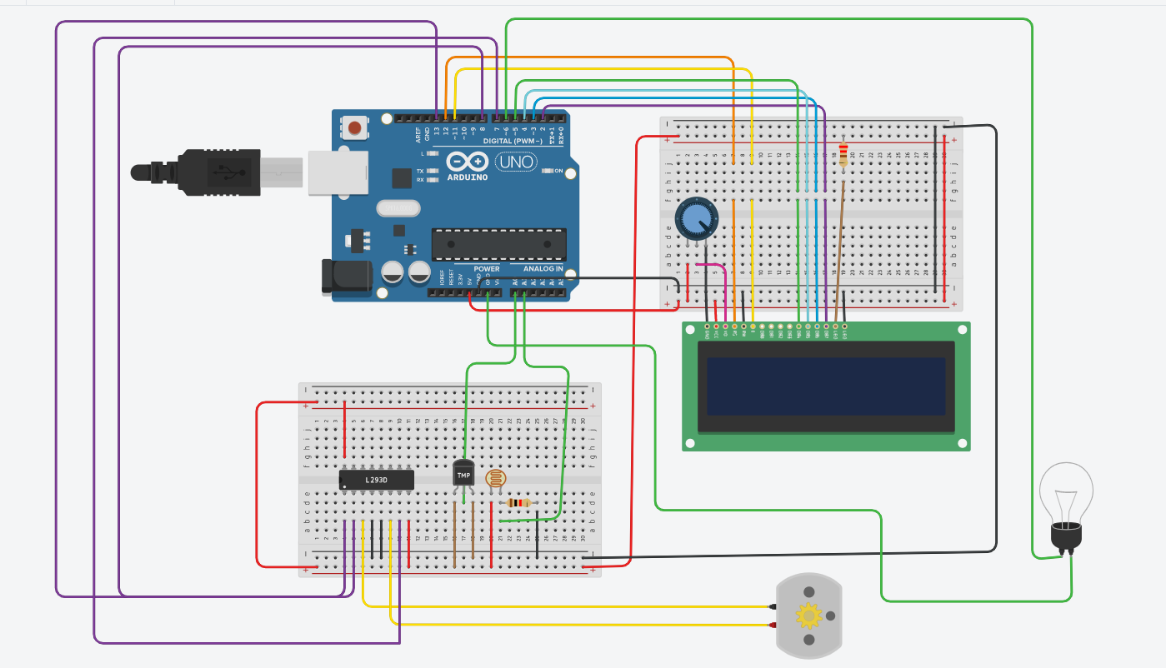

**Coding**

#include <LiquidCrystal.h> // includes the LiquidCrystal Library

LiquidCrystal lcd(12,11,5,4,3,2); // Creates an LC object. Parameters: (rs, enable, d4, d5, d6, d7)

void setup()

{

lcd.begin(16,2);

pinMode(13, OUTPUT);

pinMode(8, OUTPUT);

pinMode(6,OUTPUT);

pinMode(7, OUTPUT);

digitalWrite(13, HIGH);

}

void loop()

{

float Voltage=analogRead(A0)*0.004882814;

float degreesC = ( Voltage - 0.5 ) * 100;

lcd.setCursor(3,0);

lcd.print("Temp :");

lcd.setCursor(8,0);

lcd.print(degreesC);

if (degreesC<27)

{

lcd.setCursor(4,1);

lcd.print("TOO COLD");

digitalWrite(6,LOW);

}

if (degreesC>30)

{

lcd.setCursor(4,1);

lcd.print("TOO HOT");

digitalWrite(8, LOW);

digitalWrite(7, HIGH);

digitalWrite(6,HIGH);

delay(400); // Wait for 1000 millisecond(s)

}

if (degreesC<=30)

{

digitalWrite(8, LOW);

digitalWrite(7, LOW);

delay(400);

}

delay(1000);

lcd.clear();

int ldr=analogRead(A1);

lcd.setCursor(1,0);

lcd.print("Intensity");

lcd.setCursor(12,0);

lcd.print(ldr);

if (ldr>100)

{

lcd.setCursor(4,1);

lcd.print("TOO BRIGHT");

digitalWrite(7, HIGH);

digitalWrite(6,LOW);

}

if (ldr<100)

{

lcd.setCursor(4,1);

lcd.print("TOO DARK");

digitalWrite(7, LOW);

digitalWrite(6,HIGH);

}

delay(1000);

lcd.clear();

}

**Conclusion**

For Sure involving automation in Green House, which involves cultivation of crops throught the year in a well-established condition is going to change the planting system. In short this concept is going to revolutionarize the entire cultivation system.